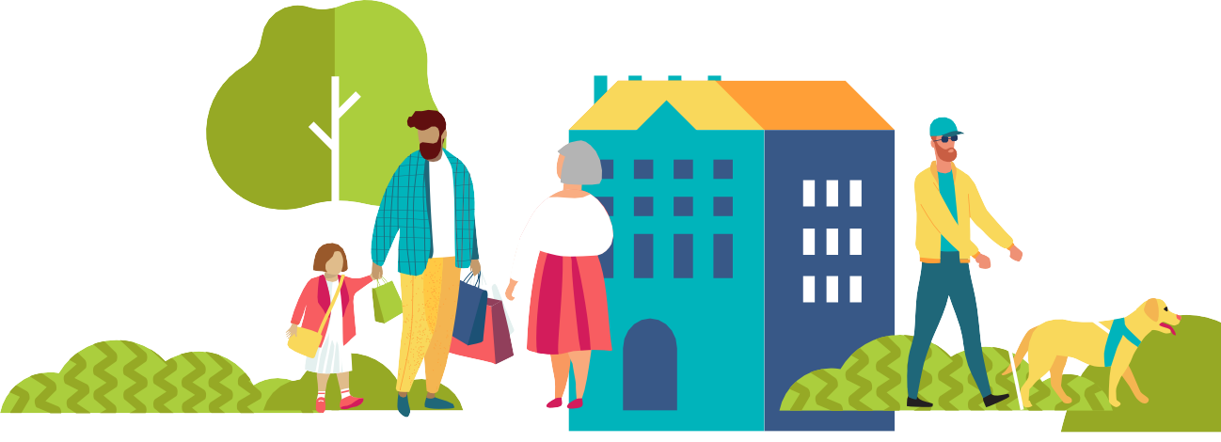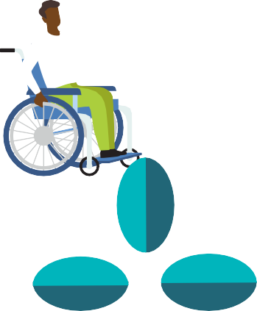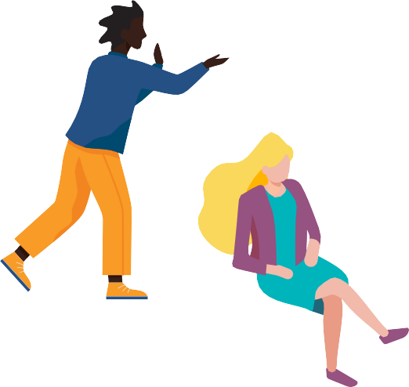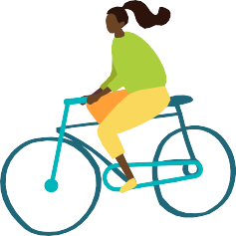MAY IS MENTAL HEALTH MONTH

MHANATIONAL.ORG/MAY

LOOK AROUND, LOOK

WITHIN
2023 OUTREACH TOOLKIT

THIS CAMPAIGN IS SUPPORTED BY CONTRIBUTIONS FROM
JANSSEN: PHARMACEUTICAL COMPANIES OF JOHNSON & JOHNSON AND OTSUK A AMERICA PHARMACEUTICAL, INC.

As humans, our overall health is significantly affected by our natural and built environment: where we are born, live, learn, work, play, and congregate all influence our health. While we often think of these environmental factors (sometimes called the “social determinants of health,”or the“vital conditions for well-being”) as relating largely to our physical health, it’s important to consider the effect of our environment on our mental health and well-being as well. This opens the door to consider education, economic stability, social connections, neighborhood, community infrastructure, and access to care. What we know for sure is that there are many factors that contribute to mental well-being, and we all benefit from stable environments, strong communities, and ready access to needed services.

During this year’s Mental Health Month, which we proudly started in 1949, Mental Health America invites you to Look Around, Look Within as we consider every part of our environment and its effect on our mental health and well-being. This year’s Mental Health Month toolkit provides free, practical resources on how to support your mental health, and the health of those in your community, within every part of our natural and built environment.

Some aspects of our environments may be outside of our immediate control while in other areas we have the potential to make change. To that end, this toolkit provides useful suggestions for ways to adapt your surroundings to improve overall health and well-being, as well as suggestions for ways to cope when change seems out of reach.

We all have mental health, and we all have unique environments. Making our environments as healthy as possible goes a long way in improving our mental well-being.

Schroeder Stribling President and CEO, Mental Health America

For Mental Health Month this year, Mental Health America is encouraging individuals to look around and look within. From your neighborhood to genetics, many factors come into play when it comes to mental health conditions. We encourage everyone to consider how the world around you affects your mental health.

Mental Health America’s 2023 Mental Health Month toolkit provides free, practical resources, including information about how an individual’s environment impacts their mental health, suggestions for making changes to improve and maintain mental well-being, and how to seek help for mental health challenges. This year’s toolkit includes:

Media Materials
- Key Messages
- Drop-In Article
- May is Mental Health Month Proclamation

Social Media
- Sample Post Language
- Shareable Images for Facebook, Twitter, and Instagram
- Pop Under (Horizontal) Web Banners
- Wide Skyscraper (Vertical) Web Banners

Posters
- Tips Calendar (Horizontal)
- Mental Health Month Poster (Vertical)
- Screening Poster (Vertical)

Fact Sheets
- Safe and Stable Housing
- Healthy Home Environments
- Neighborhoods and Towns
- The Outdoors and Nature

Worksheets
- Shaping Your Home Environment
- Opening Your Mind to the Outdoors

Other
- Outreach Ideas
- Additional Resources
- Zoom Backgrounds
- Email Signature Images

We’ll be reaching out in mid-June to ask about your outreach and impact. Make sure to keep track of your efforts by doing things like:
- Counting how many handouts you distribute;
- Tracking media hits and impressions;
- Downloading analytics for social media posts during Mental Health Month;
- If you do a screening event or health fair, keep count of how many people visit your booth and/or take a screen; and
- Conducting a pre/post survey to see how you’ve increased knowledge about mental health issues among those you reach. Set up a quick survey of up to 10 questions for free online using SurveyMonkey.com.

LIKE OUR MATERIALS? WANT MORE?
MHA merchandise is available through the Mental Health America store to supplement your outreach efforts. Visit the Mental Health America store at https://store.mhanational.org.

*MHA Affiliates – One of the benefits of being an affiliate is getting a discount on materials at the MHA store. Contact Valerie Sterns at vsterns@mhanational.org if you need help getting your affiliate discount code. There will also be extra May is Mental Health Month tools for you (“Affiliate Exclusives”) on the Education and Outreach section of the Affiliate Resource Center.
QUESTIONS?
If you have further questions about Mental Health Month, please contact
Danielle Fritze, Vice President of Public Education and Design, at dfritze@mhanational.org or Emily Skehill, Director of Public Awareness & Education, at eskehill@mhanational.org.

WHAT YOU CAN DO AS AN INDIVIDUAL

Share information locally:
- Ask wellness-oriented businesses like your local gym, yoga studio, or health food store to put up one of the posters from this toolkit.
- Reach out to your personal and professional contacts to encourage them to download the toolkit and share its resources with their customers and employees through newsletters and social media.
- Think about other groups in your community that could benefit from downloading the May is Mental Health Month toolkit – doctors’ offices, schools, churches, synagogues, and other religious gathering places are a good start. You can be a tremendous help in getting this information to people who need it!
- Include mhanational.org/may in Facebook, Twitter, Instagram, and other platform posts so people can access the webpages that have been created for Mental Health Month and other mental health information.

Help spread the word about screening:
- Put MHA’s screening site in the bio of your Instagram profile. For example, say, “Check up on your mental health at the link below,” and link to mhascreening.org in the website blank.
- Take a screen at mhascreening.org and share that you “took a check-up from the neck up.” Encourage others to do the same.

Create a personal fundraiser:
During Mental Health Month, you can show your support for Mental Health America by creating a personal fundraiser in just a few simple steps. It’s a great way to share your story, create awareness, and raise money for Mental Health America’s important work. Visit mhanational.org/may for tips on getting started and create a fundraiser today to make a difference!
- Share why mental health matters to you or share your screening story.
- Incorporate mental health fast facts into your fundraiser. Get them at www.mhanational.org/mentalhealthfacts.
- If gaming is your thing, try starting a fundraiser on Twitch.

Call or email your elected officials and let them know why you think mental health should be a priority:
- Ask your governor or mayor to declare May as Mental Health Month. Use the sample proclamation in the toolkit.
- Get in touch with your senators: www.senate.gov/senators/senators-contact.htm
- Contact your representative. Find yours using the ZIP code search feature in the top right at www.house.gov.
- Check out MHA’s most recent State of Mental Health in America report and find out where your state ranks and share with your elected officials: www.mhanational.org/issues/state-mental-health-america
- Share detailed data about suicidal thinking, depression, psychosis, and trauma across your state and county from www.mhanational.org/mhamapping/mha-state-county-data.
- Check out MHA’s series of reports on Communities in Need Across the U.S. during COVID-19:
  - Suicide: www.mhanational.org/research-reports/suicide-and-covid-19-communities-need-across-us
  - Severe Depression: www.mhanational.org/research-reports/severe-depression-and-covid-19-communities-need- across-us
  - Trauma: www.mhanational.org/research-reports/trauma-and-covid-19-communities-need-across-us
  - Psychosis: www.mhanational.org/research-reports/psychosis-and-covid-19-communities-need-across-us

Get your employer involved:
- Ask company leadership to recognize and celebrate Mental Health Month in May.
- Share why mental health should be a priority in the workplace with the infographic at www.mhanational.org/sites/ default/files/workplace/toolkit/Prioritizing-Mental-Health-Workplace.pdf.
- Request support to host a mental health campaign during May with the sample letter at www.mhanational.org/sites/ default/files/workplace/toolkit/Building-Case-WPMH.pdf.
- Suggest they share information in company-wide communications and put up the posters from this toolkit in breakrooms and other common spaces.
- Help bring a wellness or mental health speaker to your workplace by contacting your local MHA affiliate: arc.mhanational.org/find-affiliate.

Share your story
- Post on social media about your own mental health journey.
- Write something for listservs you are a part of, alumni newsletters, blogs, students newspapers – your story really does matter! And people want to hear it!
- Contact your local TV station or student TV station and share your mental health story.

Reach out individually
- Think about who you interact with on a daily basis that would find this information useful for themselves or others.
- Think about friends or family who you have been wanting to talk to about mental health – Mental Health Month is the perfect time to start the conversation.

Show your support
- Shop MHA’s online store to stock up on your mental health awareness swag: store.mhanational.org.
- Donate to MHA or one of its affiliates during May. Find your local affiliate by visiting arc.mhanational.org/find-affiliate.

WHAT ORGANIZATIONS CAN DO
- Organize a community run or walk for mental health (these can also be done virtually). Reach out to your local media for assistance in promoting the event. Email your partners, family members and friends, donors, and local officials inviting them to participate.
- Host a mental health screening or other educational event at a local venue (e.g., town hall, firehouse, church, mall, or library). Have computers or tablets available for people to go to www.mhascreening.org. Make sure to have a printer so people can print their results. If an in-person event isn’t possible, host a webinar or Facebook Live event.
- Plan an advocacy event. This could be a day at your state capitol or an email campaign. Invite advocates, consumers, concerned citizens, and community and business leaders to reach out to policymakers to discuss your community’s mental health needs.
- Team up with other local mental health and wellness organizations to host a community meet-and-greet.

WHAT YOU CAN DO FOR STUDENTS

Host a Q&A with a mental health professional:
- Invite students to write anonymous questions about mental health conditions and how to take care of their mental health. Have the school counselor answer the questions and have teachers read answers to the class.
- Choose a topic and host an “Ask Me Anything” -style chat online for parents with a clinician or representative from your local department of behavioral health. Promote the event and invite participants to ask the expert any questions they have regarding mental health.

Share stories and information:
- Ensure your students are aware of and know how to access available resources.
- Include mental health as part of the conversation in alumni newsletters, department-wide communications, student life, and social media.
- Direct people to MHA’s Mental Health Month Toolkit, www.mhanational.org/may, in your messaging for the month.
- Host mental health monologues. Invite students to submit anonymous stories to be performed by student actors – or the individuals themselves – at an assembly or record them and share the video.
- Lime green is the official awareness color for mental health – coordinate a day, such as a spirit day or “paint the school green” day, to celebrate and honor mental health awareness.
- Access additional resources specifically designed for students, parents, and teachers at mhanational.org/back-school.

WHAT BUSINESSES CAN DO
- Post one or both of the toolkit posters in your office or business.
- Use the drop-in article from this year’s toolkit and send an email to your staff to raise awareness for mental health.
- Link to mental health resources, like an employee assistance program or telehealth services, in your company newsletter.
- Encourage workers to take an anonymous and confidential online mental health screening at www.mhascreening.org.
- Publish a blog describing how the company supports its workers’ mental health.
- Encourage employees to share personal wellness or self-care tips in newsletters or messaging channels.
- Lime green is the official awareness color for mental health – ask workers to wear green on a predetermined date in May, or light up your office building green (see instructions below).

- Plan a wellness event using these tips at www.mhanational.org/sites/default/files/workplace/toolkit/12-Tips-Planning- Wellness-Event.pdf.
- Host an in-person mental health training, “lunch and learn,” or webinar.
- Connect with one of MHA’s affiliates and bring a speaker to your workplace. Find your local affiliate by visiting arc.mhanational.org/find-affiliate.
- Shop MHA’s Store, store.mhanational.org, for gifts that can be used to reward workers and spread awareness about mental health.
- Donate a portion of your proceeds to MHA or one of its affiliates during May. Find your local affiliate by visiting arc.mhanational.org/find-affiliate.
- Invite a wellness professional, like a clinician, to do a “social media takeover” and allow them to share information about workplace wellness or mental health within your industry and take questions on your social media for a whole day.
- Develop or improve workplace policies that uplift workers, ensure they are valued and heard, and improve an organization’s overall culture of well-being by downloading MHA’s Workplace Mental Health Toolkit.
- Use the sample posts from this toolkit or share posts from MHA’s social media accounts on your organization’s social media networks: LinkedIn, Twitter, Instagram, Facebook, etc. each day to raise awareness of May is Mental Health Month activities. Make sure to tag MHA’s profile so we can see it!
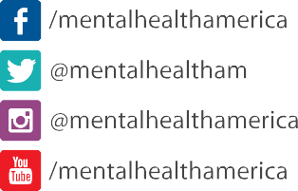

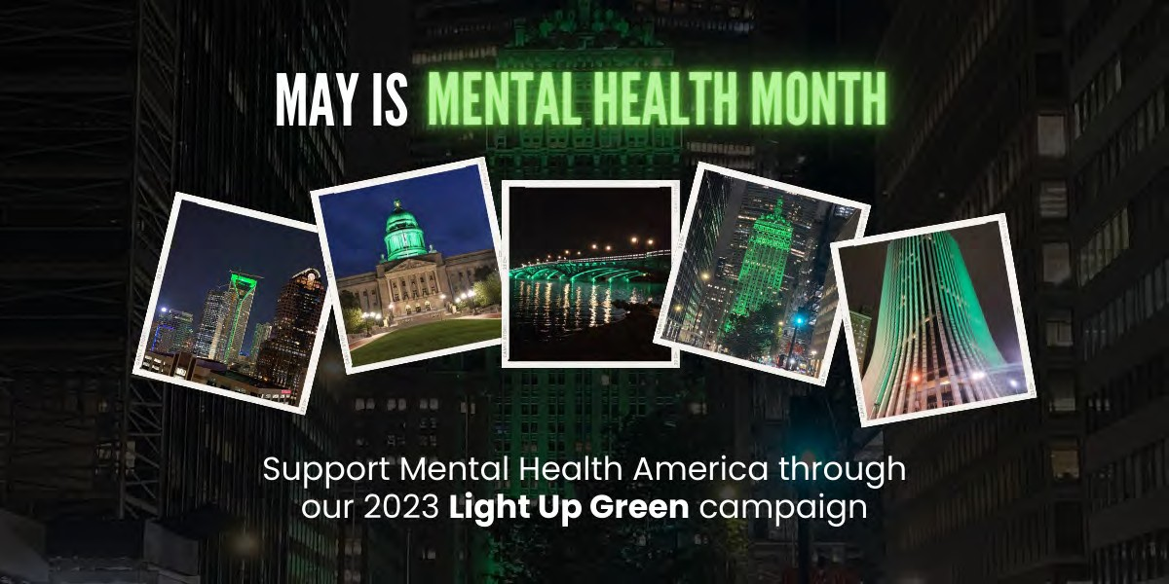

HELP US LIGHT UP GREEN FOR MENTAL HEALTH MONTH!
Mental Health America would like to enlist your help with a coordinated effort to reach out to buildings and landmarks across the country with a request to light up green for Mental Health Month. Our goal is to light up as many buildings as possible on the evening of May 1, 2023 (your local area building may want to light up on a different date or if they already traditionally light up on a different date – that’s fine too). It would be great if the building can light up for the first week of May or even the entire month. Email Jackie Zimmermann at jzimmermann@mhanational.org to let her know your city/state, which building you’ve requested be green-lit, and if your request was approved.

THE L. L. BEAN FEEL- GOOD CHALLENGE
In recognition of Mental Health Month and the mental health benefits of time outside, L.L.Bean invites you to participate in its Feel-Good Challenge, where people across the country work together towards a combined goal of 500,000 hours outside during the month of May. L.L.Bean is donating $25,000 to Mental Health America – and will donate $50,000 if the challenge is met during May.

Since this is a combined challenge, you only need to spend the time that’s right for you, whether that’s hours or minutes. Even a small amount of time outside can make a big impact on one’s mental well-being. Through your joint efforts, you’ll raise awareness of the importance time outside has on mental health. Plus, you’ll have a wonderful time outdoors doing the things you love – or maybe even trying something new.

Visit mhanational.org/llbean to learn how to participate and together we can raise awareness for mental health and the feel- good benefits of time spent outdoors.

Feel free to supplement these key messages with the assorted statistics and tips included on the fact sheets.

GENERAL
- For Mental Health Month this year, Mental Health America is encouraging individuals to look around and look within. From your neighborhood to genetics, many factors come into play when it comes to mental health conditions. We encourage everyone to consider how the world around them effects their mental health.

- Mental Health America’s 2023 Mental Health Month toolkit provides free, practical resources, including information about how an individual’s environment impacts their mental health, suggestions for making changes to improve and maintain mental well-being, and how to seek help for mental health challenges.

- Your surroundings can impact if, how, and when your needs are met, which in turn affects your mental health. However, you can take steps to change your space and protect your well-being.
- If you constantly feel worried or sad about where you live, one of the quickest and easiest ways to determine whether you are experiencing symptoms of a mental health condition is to take a mental health screening at mhascreening.org.

HOUSING STABILITY AND HOME ENVIRONMENT
- Having safe, stable, and healthy home conditions set the foundation for achieving and maintaining good mental health.

- For many people, not having a true “home base” to consistently return to can leave them feeling distressed, disconnected, or isolated. Stable housing allows individuals to develop routines and connections to their local community, which are beneficial for mental health.
- Wherever you call “home,” it should give you feelings of comfort, support, and calmness. If not, there are things you can do to your space to help you be more productive, reach your goals, and improve your mental health.

COMMUNITY
- The area, or ZIP code, that you live in plays a significant role in how healthy you are.
- A strong sense of community within neighborhoods protects mental health through shared support, resources, and joy.
- Challenges like gentrification, community violence, and lack of access to resources can negatively impact mental health. While many of these can be out of your control, being an advocate for change and making healthy community connections can bring hope.

NATURE
- Spending time in nature is linked to many positive mental health outcomes, including improved focus, lower stress, better mood, reduced risk of developing mental health conditions, and a sense of connection to yourself, community, and purpose.
- Being around nature doesn’t have to mean hiking in a forest. It can be walking in a park, bringing a plant inside, or sitting in your backyard.

Look Around, Look Within: Your surroundings say a lot about your mental health

Take a moment to consider your surroundings. Do you feel safe? Do you have access to health care and grocery stores? Does your home support you, both physically and mentally?
This Mental Health Month, challenge yourself to look at your world and how different factors can affect your mental health.

Where a person is born, lives, learns, works, plays, and gathers, as well as their economic stability and social connections, are part of what is called “social determinants of health” (SDOH). The more these factors work in your favor means you are more likely to have better mental well-being. However, when it seems like the world is working against you, your mental health can suffer.

While many parts of your environment can be out of your control, there are steps you can take to change your space and protect your well-being.

- Work toward securing safe and stable housing: This can be challenging due to finances, age, and other reasons, but there are a few things you can try, such as reaching out to state/local agencies to secure housing, removing safety hazards in the home, or finding another space (such as a community center or friend’s home) where you can get the comfort you are missing at home.

- Focus on your home: Consider keeping your space tidy, sleep-friendly, and well-ventilated. Surround yourself with items that help you feel calm and positive.

- Create bonds with your neighborhood and community: Get to know the people living around you, join or start neighbors- helping-neighbors groups, and support local businesses to challenge gentrification.
- Connect with nature: Hike in a forest, sit in a city park, bring a plant inside, or keep the shades open to absorb natural light.

If you’re taking steps to improve your surroundings but are still struggling with your mental health, you may be experiencing signs of a mental health condition. Take a free, private screening at mhascreening.org to help you figure out what is going on and determine next steps.

The world around us can be both positive and negative – bringing joy and sadness, hope and anxiety. Learn more with Mental Health America’s 2023 Mental Health Month toolkit, which provides free, practical resources, such as how an individual’s environment impacts their mental health, suggestions for making changes to improve and maintain mental well-being, and how to seek help for mental health challenges. Go to mhanational.org/may to learn more.

Encourage your local public officials to go on the record in support of mental health. Below, please find a sample proclamation that designates May as Mental Health Month. An official signing of a proclamation is a perfect occasion for a news event, photo opportunity, or other activity.

Mental Health Month 2023 “Look Around, Look Within”
WHEREAS, the area that someone lives in plays a significant role in their overall health and well-being; and
WHEREAS, surroundings can impact if, how, and when a person’s needs are met, which in turn affects mental health; and

WHEREAS, having safe, stable, and healthy home conditions set the foundation for achieving and maintaining good mental health; and

WHEREAS, with early and effective interventions, those individuals with mental health conditions can recover and lead full, productive lives; and

WHEREAS, each business, school, government agency, health care provider, organization, and citizen shares the burden of mental health problems and has a responsibility to promote mental wellness and support prevention efforts.

THEREFORE, I [NAME OF PUBLIC OFFICIAL], do hereby proclaim May 2023 as Mental Health Month in [STATE OR COMMUNITY]. As the [TITLE OF LOCAL OFFICIAL], I also call upon the citizens, government agencies, public and private institutions, businesses, and schools in [STATE OR COMMUNITY] to recommit our community to increasing awareness and understanding of mental health, the steps our citizens can take to protect their mental health, and the need for appropriate and accessible services for all people with mental health conditions.

DOWNLOAD THE TOOLKIT:
- This #MentalHealthMonth, Mental Health America invites you to #LookAroundLookWithin to learn about how your surroundings can impact mental health. Learn more: mhanational.org/may

- Download Mental Health America’s #MentalHealthMonth toolkit to learn about how your surroundings can impact mental health: mhanational.org/may #LookAroundLookWithin

TOOLKIT TOPICS:
- Stable housing allows individuals to develop routines and connections to their local community, which are beneficial for mental health. Download Mental Health America’s #MentalHealthMonth toolkit to learn more: mhanational.org/may #LookAroundLookWithin

- #MentalHealthMonth is a good time to #LookAround and adjust your space at home to help you be more productive, reach your goals, and improve your mental health. Learn more: mhanational.org/may

- Did you know your ZIP code plays a significant role in how healthy you are? This #MentalHealthMonth, Mental Health America invites you to #LookAroundLookWithin to learn about how your surroundings can impact mental health. Download the toolkit: mhanational.org/may

- Spending time in nature can lead to positive mental health outcomes, such as improved focus, lower stress, and better mood. Learn more: mhanational.org/may #LookAroundLookWithin

SCREENING:
- #MentalHealthMonth is a good time to #LookWithin and check in on your mental health. Take a free mental health test at mhascreening.org

- Taking a mental health test is one of the easiest ways to #LookWithin and check in on your mental health. Get screened at mhascreening.org #MentalHealthMonth

CRISIS:
- If you or someone you know is struggling or in crisis, help is available. Call or text 988 or chat 988lifeline.org. You can also reach Crisis Text Line by texting MHA to 741741.

BUILDING LIGHTINGS:
- #LookAround at all the buildings and landmarks being lit up green in honor of #MentalHealthMonth! Find a building lighting in your area: mhanational.org/may

- May is #MentalHealthMonth! Buildings across the country are lighting up green to raise mental health awareness. #LookAround and find a participating building or landmark near you: mhanational.org/may

HASHTAGS:
- #LookAround
- #LookWithin
- #LookAroundLookWithin
- #MentalHealthMonth

LINKS:
- www.mhascreening.org
- www.mhanational.org/may

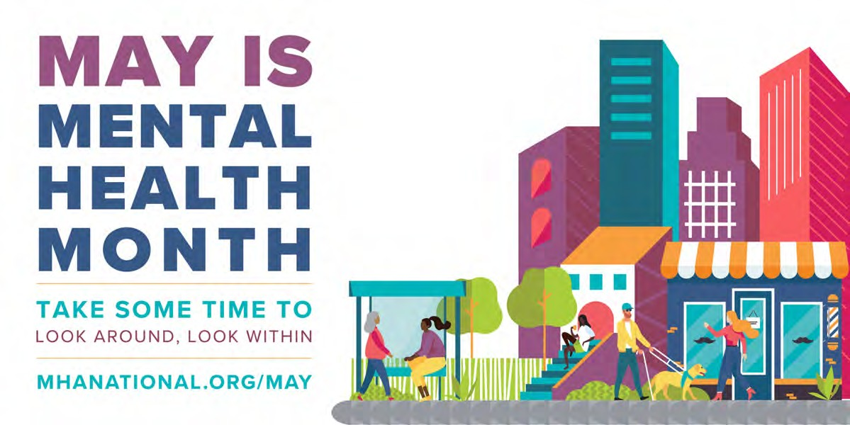

Download and save the images provided for use on your social media platforms or websites. All images can be accessed by visiting https://mhanational.org/mental-health-month-2023-toolkit-download and downloading the images zip file.

Email Signatures (1200 x 600 px)
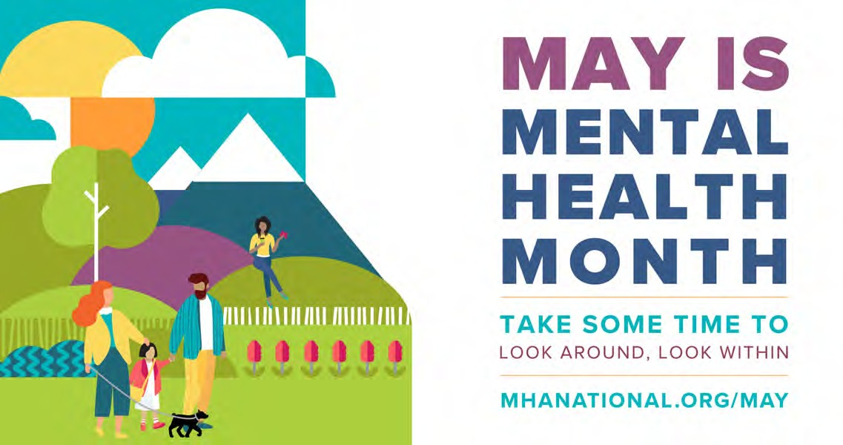

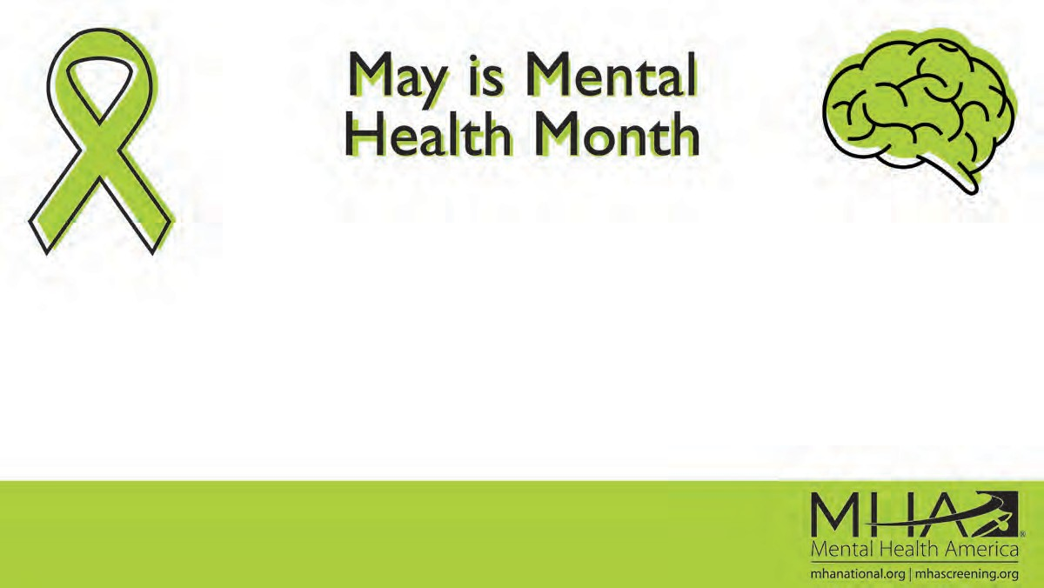Zoom Backgrounds
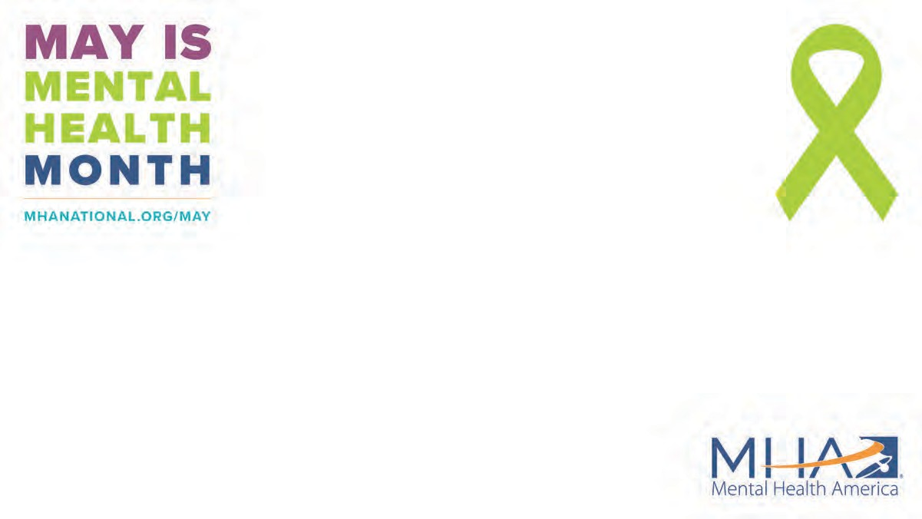

Shareable Post Images (for all social media platforms)
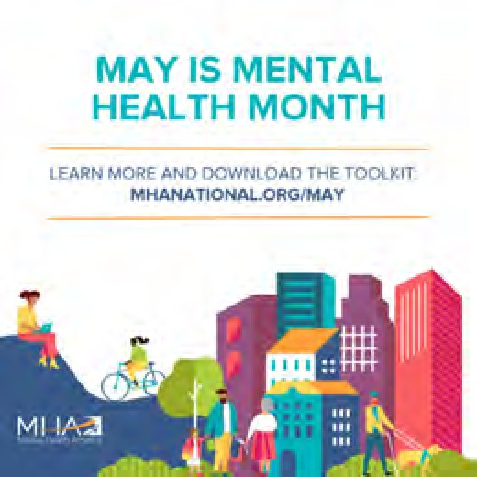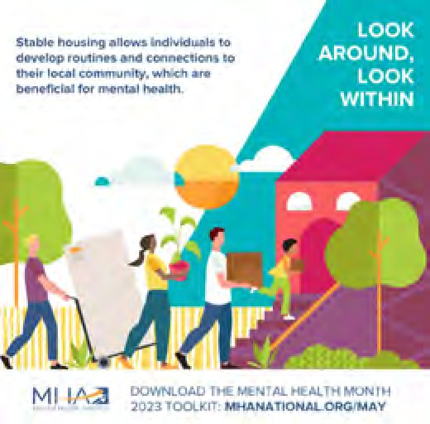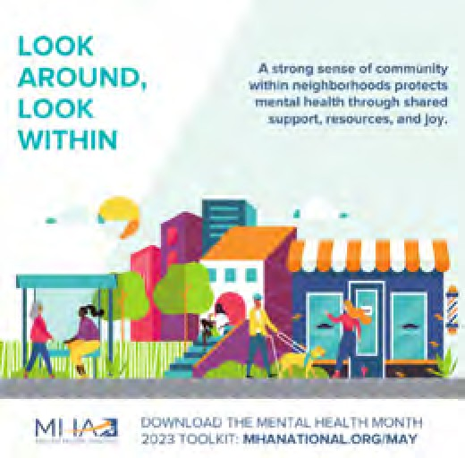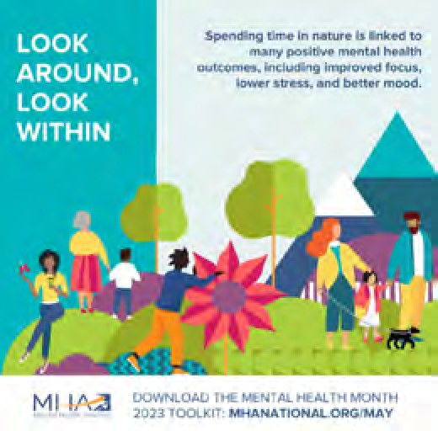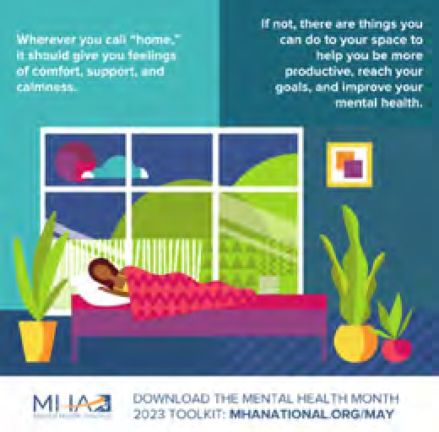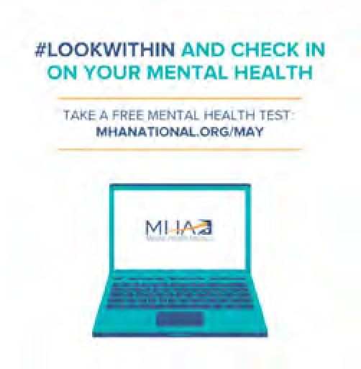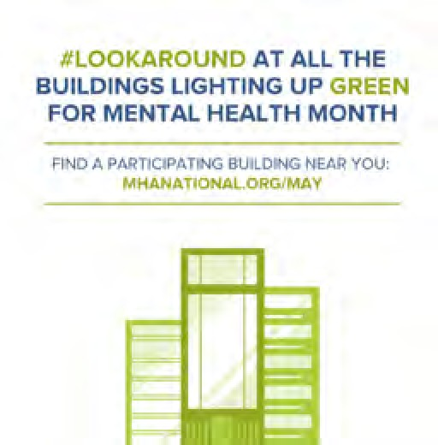

Instagram and Facebook Story Images

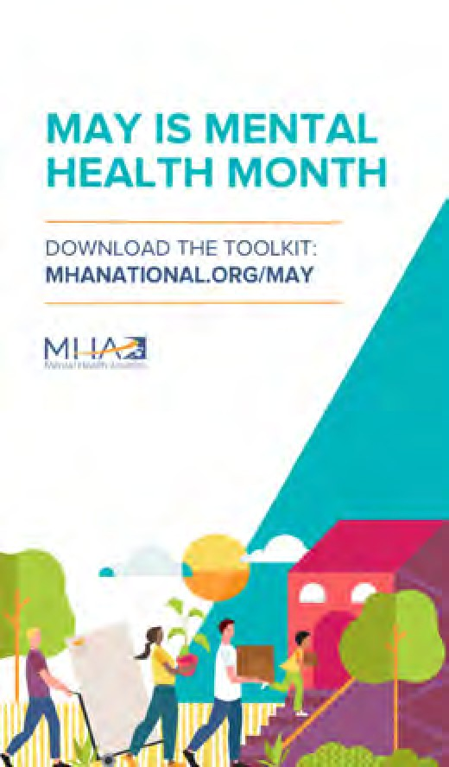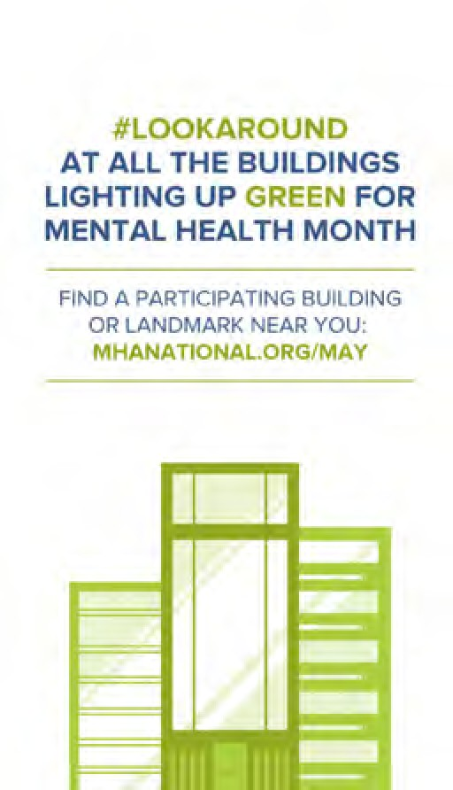

24/7 RESOURCES
MHA Screening: Online screening is one of the quickest and easiest ways to determine if you’re experiencing symptoms of a mental health condition. Our screens are free, confidential, and scientifically validated.

988 Suicide & Crisis Lifeline: The 988 Lifeline provides 24/7, free, and confidential support to people in distress – you don’t need to be suicidal to reach out. Call 1-800-273-8255 to be connected with a crisis counselor. Crisis counselors who speak Spanish are available at 1-888-628-9454.

988 Textline: When you text 988, you will complete a short survey letting the crisis counselor know a little about your situation. You will be connected with a trained crisis counselor in a crisis center who will answer the text, provide support, and share resources if needed.

Crisis Text Line: If you prefer texting to talking on the phone, text MHA to 741-741 to be connected with a crisis counselor who will help you get through your emotions.

Warmlines: Warmlines are staffed by trained peers who have been through their own mental health struggles and know what it’s like to need someone to talk to. Visit here for more information on warmlines.

RESOURCES FROM MHA:

REPORTS AND TOOLS
State of Mental Health in America Report 2023: The State of Mental Health in America report is intended to provide up-to-date data and information about disparities faced by individuals with mental health challenges and serve as a tool for change. Learn more about disparities in mental health treatment for youth of color by downloading the report.

MHA’s Workplace Mental Health Toolkit: Creating a Culture of Support and Well-being: The Workplace Mental Health Toolkit provides information on how employers and people leaders can develop or improve workplace policies that uplift workers, ensure they are valued and heard, and improve an organization’s overall culture of well-being. Download the report.

Mapping the Mental Health of Our Communities: For years, Mental Health America has provided free, anonymous, clinically validated mental health screens on our website, MHAScreening.org. Now, for the first time, our researchers and corporate partners at Lundbeck are geographically analyzing the results from millions of those mental health screens and showing you the data in near real time. This is the largest dataset of its kind, and now you can explore it at the state and county level on our powerful dashboard and in four comprehensive briefs.

Our Future in Mind Toolkit: If you want to become an advocate for mental health, the “How to become a mental health advocate in 7 steps” guide is for you. This toolkit is born from Our Future in Mind, a two-day mental health summit hosted by Mental Health America and IDONTMIND, featuring conversations from mental health experts and advocates highlighting their work and pathways to activism.

ONLINE ARTICLES

SAFE AND STABLE HOUSING
- Housing
- Social Determinants of Health
- When Home Life is Hard – Adults
- When Home Life is Hard – Youth
- Understanding Abuse
- My Family Members Are Abusive
- Eliminating Toxic Influences

HEALTHY HOME ENVIRONMENTS
- Working From Home with ADHD
- How Can I Manage My Mental Health While Working from Home?
- 5 Ways to Stay Focused When You Have No Dedicated Workspace
- How Do I Stay Clean and Sober While I’m Stuck at Home?
- Co-occurring: Mental Health and Substance Abuse
- Helping at Home – Tips for Parents
- How to Deal with Homesickness in College
- How to Deal with Roommate Problems
- I Can’t Sleep!
- Sleep Complications in Recovery
- Get Enough Sleep
- Sleep Deprivation
- How Blue Light Affects Sleep
- Should I Kick out My Adult Child?
- Creating Healthy Routines

NEIGHBORHOODS AND TOWNS
- Rural Mental Health Crisis
- Talking to Kids About Fear and Violence
- How Can I Get Mental Health Help in a Small Town?
- Community Care
- How You Can Address Both Mental Health and Hunger in Your Community
- Social Support: Getting and Staying Connected
- We Build Our Community, and Then It Builds Us
- Feeling Lonely in a Crowd
- I Don’t Feel Like I Belong Anywhere

THE OUTDOORS AND NATURE
- MHA Partnership to Prioritize the Power of Going Outside
- 18 Ways to Cope with Frustration

WEBINARS
- Safety Not Stigma – Reframing the Way We Talk About Guns and Violence
- Handling the Holidays in a Non-LGBTQ+ Affirming Environment
- Preventing and Healing from Child Abuse and Neglect
- Supporting LGBTQ+ Youth in Our Communities
- Workplace Mental Health: Employer Perspective
- The Rural Mental Health Crisis
- Providing Peer Support in a Rural Environment

EXTERNAL RESOURCES
Resources mentioned below come from MHA’s network of trusted partners and supporters.

AAKOMA Project: AAKOMA works to build the consciousness of youth of color and their caregivers on the recognition and importance of mental health, empowering youth and their families to seek help and manage mental health, and influence systems and services to receive and address the needs of youth of color and their families.

Anxiety and Depression Association of America (ADAA): ADAA is an international nonprofit organization dedicated to the prevention, treatment, and cure of anxiety, depression, OCD, PTSD, and co-occurring disorders through the alignment of science, treatment, and education.

Caregiver Action Network (CAN): CAN is the nation’s leading family caregiver organization working to improve the quality of life for the more than 90 million Americans who care for loved ones with chronic conditions, disabilities, disease, or the frailties of old age. Individuals can reach out for guidance and support to their dedicated Caregiver Help Desk.

Center on Race, Poverty & the Environment (CRPE): CRPE is a national environmental justice organization providing legal, organizing, and technical assistance to grassroots groups in low-income communities and communities of color. Their work focuses on solutions involving climate justice, sustainable agriculture, and toxic-free communities. The CRPE believes social

change comes from the ground up and that low-income communities and communities of color most impacted by pollution need to define the problems and craft the solutions for their communities.

Faces and Voices of Recovery: Faces and Voices of Recovery works to change the way addiction and recovery are understood and embraced through advocacy, education, and leadership.

Health Equity Collaborative: The Health Equity Collaborative seeks to eliminate health disparities through the utilization of a holistic and intersectional approach to health care.

IDONTMIND: IDONTMIND is a mental health awareness campaign and lifestyle brand working to get people talking about their minds and to generate positive messaging about mental health. Check out their online journal for articles on all things mental health.

Lavender Phoenix: Lavender Phoenix builds queer and transgender Asian and Pacific Islander power to amplify voices and increase the visibility of the communities. Through organizing in the San Francisco Bay Area, they inspire and train grassroots leaders, transform values from scarcity to abundance, and partner with organizations to sustain a vibrant movement ecosystem.

L.L. Bean: Mental Health America and L.L. Bean have partnered to promote outdoor activity as a simple way to improve well- being. Learn more about the partnership here.

Mental Health Coalition (MHC): Formed to catalyze like-minded communities to work together to destigmatize mental health and empower access to vital resources and necessary support for all, the MHC connects individuals to a range of different resources from Coalition members.

The Mental Health Collaborative: The Mental Health Collaborative works to build resilient communities through mental health education and awareness, decreasing stigma, and opening the door to conversations about mental health. They train schools, organizations, and communities in mental health literacy – the foundational education that all of us need to promote our best mental health.

Rural Minds: Rural Minds serves as the informed voice for mental health in rural America and provides mental health information and resources.
Southern Echo: Southern Echo works to empower Black and low-income communities throughout Mississippi and the southern
U.S. with the knowledge, skills, and resources needed to impact and demand accountability of the political, education, economic, and environmental systems to address the needs of communities through comprehensive organizing, leadership development, training, and technical assistance programs.

The Praxis Project: The Praxis Project is a national nonprofit that works in partnership with national, regional, state, and local partners to achieve health equity and justice for all communities.

wikiHow: wikiHow is an online community consisting of an extensive database of how-to guides. Check out their course, created in collaboration with MHA: Boost Your Well-Being: wikiHow’s Healthy Mind Masterclass.

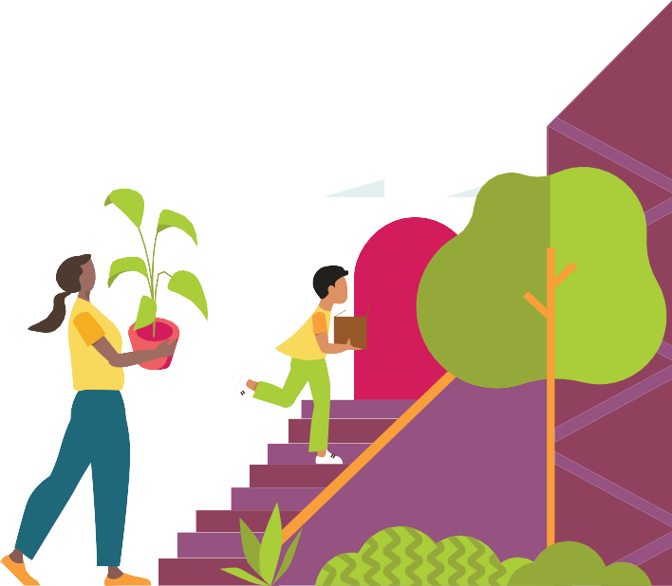
SAFE AND STABLE HOUSING
Housing is more than just protection from the outdoor elements. Safe and stable housing is a basic need, and it can be difficult or impossible to care for your mental health if that need is not met.

STABLE HOUSING

Stable (or secure) housing means that you aren’t living in uncertainty about your housing situation and generally have a choice over when to move. The opposite of this – housing instability – can mean you’re facing a number of different challenges, like struggling to pay rent, overcrowding in shelters, moving frequently, or spending most of your income on housing.
If you face the possibility of homelessness or move spaces frequently, the stress and anxiety of those situations can wear on you after a while, especially if you’re moving without much notice. Frequent moves also make it hard to develop routines and connections to your local community, which are beneficial for mental health. For many people, not having a true “home base” to consistently return to can leave them feeling distressed, disconnected, or isolated.

WHAT CAN I DO IF I’M EXPERIENCING UNSTABLE HOUSING?
Seek support in finding housing. Each state has information on identifying services. The U.S. Department of Housing and Urban Development (HUD) has information on local homelessness assistance and help with preventing housing loss. Their portal, hud.gov, can direct you to state-specific resources. If you meet low-income guidelines, you might qualify to live in different types of public housing. You can locate your housing authority at affordablehousing.com.
Build your connection to self. It sounds cliché, but feeling at home in your mind can help you cope when your housing is uncertain. Having healthy routines that you can carry out almost anywhere (like deep breathing every morning or practicing gratitude before going to sleep) is a great way to establish that. Practices of mindfulness in challenging situations can help you handle what is causing stress and improve your emotional state.1

PSYCHOLOGICAL SAFETY

Only about 15% of adults in the U.S. live alone – meaning most people share living space with family members, roommates, or others. Small disagreements among household members are totally normal, but being scared of the people you live with might mean you’re in a problematic or abusive situation. The location of your housing can also play a role if you are feeling unsafe. Living in an unsafe neighborhood not only affects physical safety but can also impact mental health. Neighborhoods are places where you should be able to build a social network – places to help mental health thrive. An unsafe neighborhood can limit your ability to connect with others and find community.
Experiencing – or even witnessing – physical, emotional, or psychological abuse is traumatic. It can have long-lasting effects on your mental health and lead to conditions like depression, anxiety, or PTSD.2 New research shows that
women who have experienced domestic abuse have three times the risk of developing a mental health condition compared with those who have not.3
Experiencing abuse is never your fault.
You deserve to feel safe.

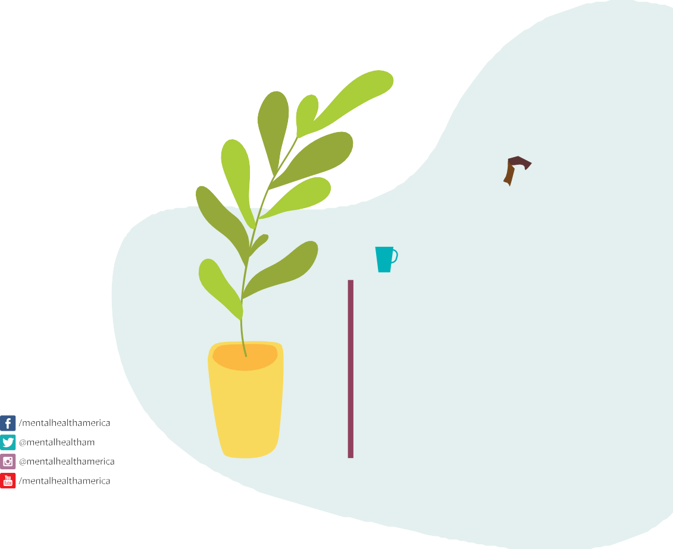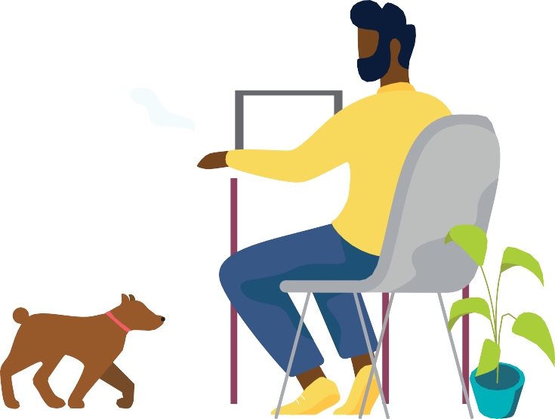WHAT CAN I DO IF I FEEL UNSAFE?

Having safe, stable, and healthy home conditions set the foundation for
achieving and maintaining good mental health.

If you’re taking steps to improve your housing situation but are still
struggling with your mental health, you may be experiencing signs of a mental health condition – take a free, private
screening at mhascreening.org to help you figure out what is going on and determine next steps.
Tell someone you trust. Feeling unsafe at home is a big burden to carry alone – sharing with someone can help you feel like you have a safety net. Learn more about home safety at bit.ly/3F3vsIc.

Find another place to feel like home. Get familiar with a community center, cafe, place of worship, or friend’s home so that you have a place of comfort. If you are scared for your safety or experiencing abuse, it is important to remove yourself from the situation. You can call the domestic violence hotline at 800-799-7233 or visit domesticshelters.org/help to locate a shelter near you. Call 911 if you are in immediate danger and cannot remove yourself from your home to seek help.

POTENTIAL SAFETY HAZARDS

Your home doesn’t need to be perfectly tidy, but some house basics are essential for your safety. Your living space shouldn’t have the potential to cause health issues – exposure to things like mold, toxic chemicals, and uncleaned animal mess puts you at risk of physical and mental health challenges.4 A hoarding condition can create such circumstances that put everyone living within the home at risk.

It’s also important to think through safe storage of potential dangers like weapons and addictive substances, especially if you or someone in the home has thoughts of suicide. Over half of the nation’s deaths by suicide involve a firearm, and safe storage (and proactive policies) can help lower this rate.5,6 If you’re struggling to control your substance use, you may want to get rid of those substances in your home altogether to avoid temptation. If they belong to someone else, you could ask them to keep drug(s) or alcohol out of sight or locked away.

WHAT CAN I DO ABOUT SAFETY HAZARDS?
Determine who is responsible for fixing housing-related hazards. They may be your responsibility or the responsibility of a landlord, building owner, or town/municipality.

Have a professional take care of safety hazards. Once you’ve identified who is responsible for fixing hazards, make sure a qualified professional is there to check it out or make repairs.

Add friction between you and dangerous objects and/or substances. This could look like removing items from your home, locking them up so they are harder to access, or putting other safeguards in place to keep you from engaging in the behavior you want to change. Making it harder to act on risky decisions is powerful harm reduction.

Sources available by downloading the 2023 May is Mental Health Month Toolkit at mhanational.org/may.

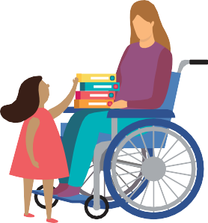
HEALTHY HOME ENVIRONMENTS
Optimizing your space to improve your mental health is something that anyone can benefit from. For those living with mental health conditions, it is one tool of many that can be used to improve and support your mental well-being.

PRACTICE TIDINESS
Keeping your living space clean is shown to promote calmness and a sense of control over your day-to-day life. Your home environment doesn’t need to be spotless, but clutter can be harmful to your mental state – contributing to depression, trouble focusing, confusion, and stress.1 Not only can clutter be distracting, but it has been shown to actually make it harder for your brain to think clearly.2 Neatness also provides predictability, which can cut down on brain fatigue and anxiety. Less time looking for lost items or getting distracted is always a good thing.

WHAT CAN I DO TO CREATE A TIDY SPACE?
Start small. If beginning to improve your space feels overwhelming, choose one area to start. Consider setting a timer each day to dedicate time toward improving your space.
Be mindful throughout your day. Instead of putting items down and adding to your clutter, get in the habit of putting them away. Small things, like putting clothes away right after they are washed, can help lessen the tasks when you go to clean later.
Practice mindfulness while cleaning. One study found that people who were mindful while washing dishes – taking time to smell the soap, feel the water, and absorb the experience – reported a 27% reduction in nervousness, along with a 25% improvement in mental inspiration.3
Once your space feels clean, think about organization. How can you maximize your space and be intentional about organizing to avoid future clutter and mess? Having a clean and organized space can help you feel in control and calm.4
Get rid of unneeded belongings. Periodically going through your place to find items to donate or get rid of can go a long way toward keeping your home minimally cluttered and clean. If you have so much clutter that you’re embarrassed to have people in your home and getting rid of possessions is a major struggle for you, you might be experiencing signs of hoarding disorder.

MAKE YOUR BEDROOM SLEEP-FRIENDLY

For good mental health, it’s particularly important to pay attention to your sleeping conditions. Poor sleep is known to sometimes trigger or worsen mental health challenges, while getting quality rest can protect your mental health. Your surroundings come into play with things like temperature, light, and noise.5

WHAT CAN I DO TO IMPROVE MY SLEEP?
Keep it cool. The ideal sleeping temperature is 60-67°F. Keep a fan around for warm nights, and blankets nearby for cold nights.6
Lessen excess noise. If you live with others or in a busy area, distracting sounds like traffic or neighbors might keep you up at night. You can use a noise machine, or find sleep music or white noise online to drown out annoying sounds. If no sound at all is what you need for a restful night’s sleep, you could try using ear plugs.
Make your space dark. Try to limit the amount of light in your space, including electronics such as your phone or television, which create blue light that can disrupt your body’s circadian rhythms.7 Use blinds or blackout curtains to keep outside light from getting in – especially if you work nightshift and need to sleep during the day.

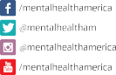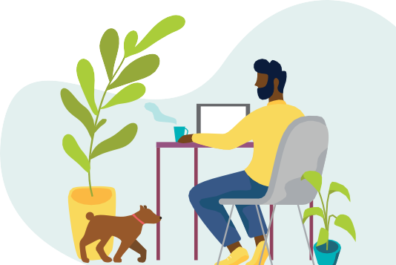 CREATE COMFORT
Sources available by downloading the 2023 May is Mental Health Month Toolkit at mhanational.org/may.

If you’re taking steps to improve your surroundings at home but are
still struggling, you may be experiencing signs of a mental health condition.
Take a free, private screening at mhascreening.org to help you figure out what is going on and determine next steps.
A big part of a mentally healthy living situation is feeling like your space gives you comfort, support, and calming energy. This could look like keeping comfort items around. Your favorite blanket, a meaningful gift, or a candle in your favorite scent can go a long way in helping you feel more at home. Your home can also impact your mental health based on colors, natural light, and set-up. Appropriate light, furnishing textures and patterns, and room organization can help reduce signs of anxiety and depression.8

WHAT CAN I DO TO CREATE COMFORT?
Notice how you feel in different parts of your home. What spaces feel the most comfortable and why? Consider how you can include those elements in other areas of your home that don’t have the same energy.
Know that there’s no one-size-fits-all ideal home environment. You might need to rework things a few times to find what’s best for you.
Personalize your space. Put up photos of you and your loved ones, display your favorite belongings, and decorate with the intention of creating a specific feeling, like joy, creativity, or peace.
Don’t let finances prevent you from changing your space. Being more comfortable in your space might be as simple as moving furniture around, swapping wall art between rooms, or opening up your blinds to let in more natural bright light.

CHECK AIR QUALITY
Good air quality can raise oxygen levels in your brain, boosting mood and focus.9 It’s also associated with reducing the effect of stress hormones and promoting better sleep.10 While getting fresh air directly from outside is ideal (mostly because of the other benefits of nature), filtered air protects your well-being, too. You can also get a number of similar benefits from the way you breathe.
According to a 2022 literature review, 95% of studies on outdoor air pollution, mental health, and human/animal brains found that exposure to polluted air changes the brain. Of the studies, 73% reported that those exposed to above-average levels of air pollution showed more symptoms and behaviors associated with mental health challenges.11
Many studies on different breath awareness and regulation techniques have found them to reduce symptoms of stress, depression, and PTSD.12

WHAT CAN I DO TO BREATHE BETTER?
Check the air quality. Go to airnow.gov to see the air quality in your ZIP code.
Open windows. Let air in as weather allows and if you live in an area with low levels of air pollution.
Use an air purifier. Better indoor air quality and flow can help you think more clearly.13
Do some breathing exercises. Try slowly breathing in through your nose for five seconds and out through your mouth for five seconds. The way you breathe has a strong impact on helping you regulate your emotions. Diaphragmatic breathing can improve attention and levels of cortisol (the stress hormone).14 Visit bit.ly/41PYLHP to find additional breathing exercises.

SET YOURSELF UP FOR SUCCESS

When you’re struggling with your mental health, just getting through the day can be hard, but there are things you can do to your space to help yourself be more productive and reach your goals. Ultimately, a healthy home environment will look different from one person to the next. It might take time, thoughtfulness, and multiple tries to get your space to meet your needs, but eventually it will help make your space feel right for you.

WHAT CAN I DO TO SET MYSELF UP FOR SUCCESS?
Remove barriers to healthy habits. Try putting your cleaning supplies or chore schedule in sight if you want to be better about keeping things neat, or place fresh fruit on your counter if you want to eat healthier.
Keep sensory or stim toys around the house. These types of toys can help channel your nervous energy into a healthy distraction so you’re better able to focus on tasks that require a lot of brain power.
Prep! If starting the day is hard, lay out your clothes and pack your lunch the night before so you can grab them quickly when the morning comes.

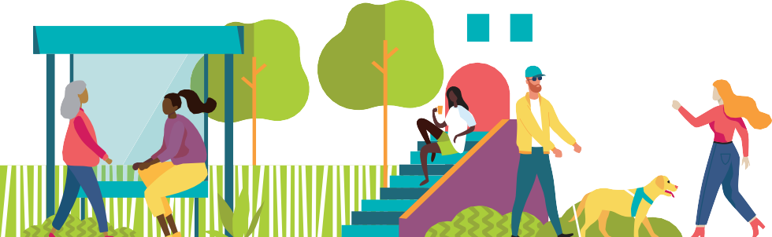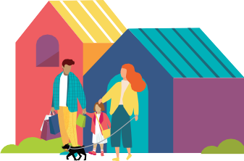
NEIGHBORHOODS AND TOWNS
Did you know that your ZIP code plays a role in your health? It might surprise you to learn that up to 60% of your health is determined by where you live.1 Your neighborhood, along with your town and larger geographical region, impacts your sense of community and belonging, and determines how easily you can access the things and services you need, including for your mental health.

ACCESS TO QUALITY RESOURCES
One of the biggest ways your location can impact your mental health is how easy or hard it is to access the things you need. This includes healthy food, safe outdoor space, quality medical care, and public transportation (which still may not get you where you need to go in a reasonable amount of time even when you do have access). Because local income taxes usually fund public services, low-income areas are often under-resourced in quality education, road maintenance, community programs, and more, which can make it difficult for people to meet their basic needs. Black, Indigenous, and people of color (BIPOC) and other marginalized communities often feel these strains the hardest.
- Roughly 6% of people in the U.S. live in a food desert, which is an area with limited options to get affordable and healthy food.2,3 Food deserts often lead to food insecurity, which is associated with increased stress and depression. In young adults, food insecurity often co-occurs with suicidal thoughts and substance use.4
- Each year, 3.6 million people in the U.S. go without health services because they don’t have a car, access to public transportation, or another way to get appointments.5
- A study on community recreation centers in California found that lower-income neighborhoods had lower-quality facilities and fewer no-cost youth programs.6

WHAT CAN I DO TO GET ACCESS?
Get to know your neighbors. The people living around you can be a big help when you need something. You can support each other with carpools, running errands, or sharing resources.
Connect with a group in your area where community members share and exchange services. You may be able to find an organized mutual aid program, or you can search for a local Facebook or NextDoor group focused on community support.

GENTRIFICATION AND POVERTY

Gentrification is when a low-income neighborhood quickly changes as wealthier people and businesses move into the area. This often forces out long-time residents and businesses as rent, mortgages, property taxes, and the general cost of living rise. People and business who are forced to move – particularly within the BIPOC community – generally end up in lower-income and under-resourced areas.7
- A 2020 study found that adults living in gentrified neighborhoods – particularly renters, low-income residents, and long-term residents – were at increased risk for serious psychological distress compared to those in low-income, ungentrified neighborhoods.8
- Hospitalization rates for mental health conditions, including schizophrenia and mood disorders, are two times higher in people displaced by gentrification compared to those who remain in their neighborhood.9
- A study on New York City neighborhoods found a 22% higher rate of anxiety or depression among children who started life in areas that gentrified than among children in areas that did not gentrify, even when controlling for income and rent.10

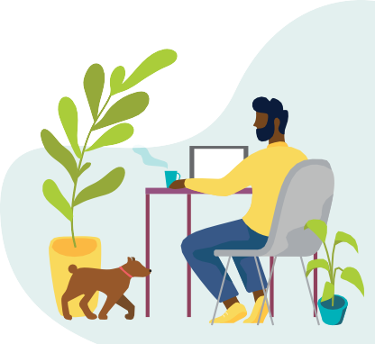WHAT CAN I DO TO PROTECT MY NEIGHBORHOOD?
Sources available by downloading the 2023 May is Mental Health Month Toolkit at mhanational.org/may.

Nowhere is perfect, and every community faces challenges. Stressing over your well-being in your neighborhood can take a toll on your mental health.
If you the area where you live is worrying you or constantly on your mind, take a free, private screening at mhascreening.org to help you figure out what is going on and determine next steps.
Support local businesses. Locally owned businesses – from coffee shops to grocery stores to home services – keep communities going. By shopping locally, you help them stay open.
Stay connected. If you are forced to relocate, try to stay connected to your original community or the people you knew from it. Many gentrified neighborhoods previously had a strong community identity and culture, and maintaining those social ties can protect your mental health.

SOCIAL CONNECTION

Feeling a sense of connection is crucial for your mental well-being. While you can find this with many people and in many places, the people you live near can provide community and social support. Your physical closeness to neighbors allows for spontaneous interactions and shared interests, which can lead to genuine friendship. Strong community among neighborhoods and nearby residents protects mental health through shared support, resources, and joy. On the other hand, you may be in a neighborhood without community, feel like an outsider, or lose your community because of gentrification – all of which can have be harmful to mental health.
- In low-income and under-resourced areas, community bonds often predict the mental health of residents. Strong social ties within neighborhoods protect well-being by fostering a sense of teamwork and community care.11
- Of children living in neighborhoods that parents perceived as “not supportive,” about 18% had a diagnosed mental health condition, compared to 13% of those living in supportive neighborhoods.12

WHAT CAN I DO TO MAKE NEARBY SOCIAL CONNECTIONS?

Be a friendly neighbor. It seems obvious, but taking the first step to wave or say “hello” can be the beginning of a fulfilling connection. You can also try to organize group gatherings.
Seek out places within your neighborhood or town. Where can you find safety, comfort, or connection? Think outside of the box of where you can find people with similar interests or commonalities to you. These could be parks, places of worship, barber shops, tattoo parlors, cafes, or libraries.

COMMUNITY SAFETY

There are many reasons people might feel unsafe in their local surroundings, including violence and mass shootings, police presence and brutality, and discrimination and harassment. These safety concerns may prevent people from engaging in outdoor or community activities, which can be harmful to physical and mental health. Even if you haven’t dealt with fear or violence yourself, witnessing or hearing about it can still impact you. The Centers for Disease Control and Prevention recently defined community violence as a “critical public health problem,” and the World Health Organization has recommended adding exposure to community violence (ECV) as a new adverse childhood experience (ACE) category.13,14
- People across the U.S. are on edge, with a quarter of Americans live in fear of being attacked in their own neighborhoods.15 Youth exposed to repeated community violence are less engaged at school and more likely to suffer from anxiety and depression.16,17
- Many predominantly BIPOC neighborhoods are over-policed, causing chronic stress and hypervigilance. This policing is often focused on low-level offenses like traffic stops or curfew violations, which research shows does not reduce crime rates but does risk escalating to police violence and cause community trauma.18,19
- LGBTQIA2S+ people living in rural areas are less likely to have protections, such as nondiscrimination laws, and more likely to have discriminatory laws, like religious exemption laws that allow service providers to discriminate.20

WHAT CAN I DO TO FEEL SAFE IN MY COMMUNITY?

Focus on community care. Crime occurs in areas where people don’t have their needs met.21 While you can’t fix everything, you can take part in keeping your neighborhood safe by providing support and resources and advocating for harm repair over punishment.
Identify safe people. Being prepared can help alleviate anxiety and fear. Know who your allies are and who you can count on if you find yourself in danger.

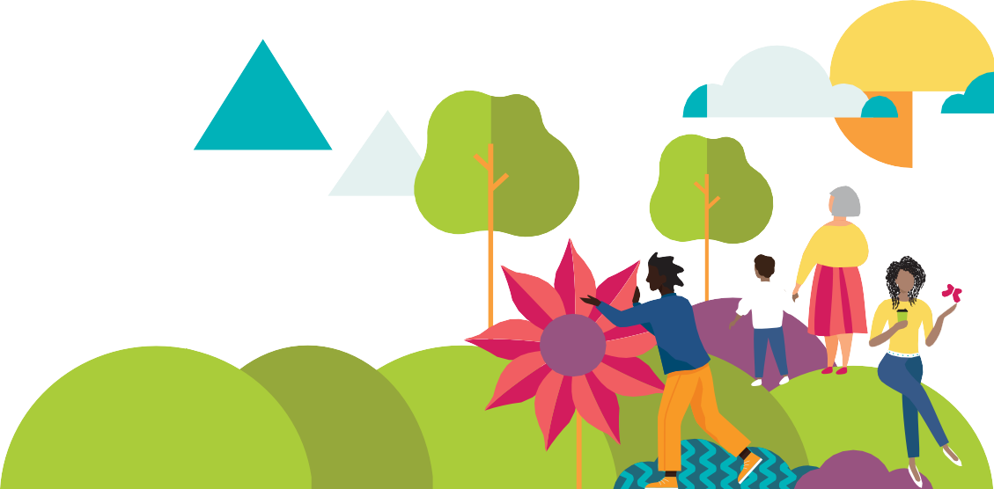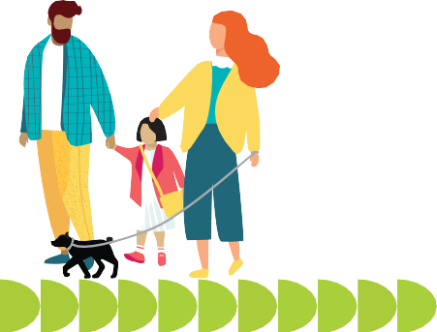
THE OUTDOORS & NATURE
Spending time in nature is linked to many positive mental health outcomes – improved focus, lower stress, better mood, and reduced risk of developing a mental health condition.1 Most studies on nature and well-being look at green spaces like parks and forests, but researchers are also beginning to look at blue spaces – places with ocean and river views. However, you don’t need a picture-perfect outdoor experience to get the benefits of nature.
Try a light box. Light therapy can help with symptoms of depression and sleep disorders. The bright light from a light box mimics natural sunlight, causing the brain to produce serotonin and regulate your internal clock.9

PLANTS & GREEN SPACE
Seventy percent of respondents to a Mental Health America Connection Survey reported wishing they had more time outdoors, ideally in nature away from their neighborhoods. Cities often have more stressors to physical and mental health, but green space (like parks and gardens) can reduce their impact. Even spending some time in your backyard (if you have one) can produce positive outcomes, and feeling connected to nature helps your mood even if you don’t spend time outdoors.1
Children living in neighborhoods with more green space had a reduced risk of developing depression, mood disorders, schizophrenia, eating disorders, and substance use disorder.2
Even being in the presence of indoor plants is worthwhile – studies have found this to improve focus, memory, and stress tolerance.3

WHAT CAN I DO TO FIND GREEN SPACE?
Don’t discount the little things. While being in the wilderness is especially nice, even city parks, a small garden, or sitting under a tree can support your mental health.
Bring the outdoors in. Adding greenery to your space can have a similar effect to seeing plants outdoors – and some, like snake plants and bamboo palms, can purify your air.4

NATURAL LIGHT

Sunlight triggers the release of serotonin and vitamin D, which are associated with boosting mood and focus and reducing stress.5 Without enough sun, these levels can drop, leading to symptoms of depression, anxiety, and other mental health challenges. Light exposure also has a direct impact on your body’s sleep-wake cycle, and consistent sleep is one of the most important factors in your well-being.
- More time spent in outdoor light is associated with lower odds of using antidepressant medications and fewer symptoms of insomnia.6
- The natural lighting of a home is known to impact how you describe your own mood. Improvements to natural lighting have a positive impact on overall emotional social well-being, particularly among women and younger population.7

WHAT CAN I DO TO GET NATURAL LIGHT?
Enjoy the sunshine. Just 10-15 minutes of sun on your arms and legs a few times a week has the potential to generate all the vitamin D you need; however, this depends on factors like the season, time of day, pollution, skin tone, and more.8

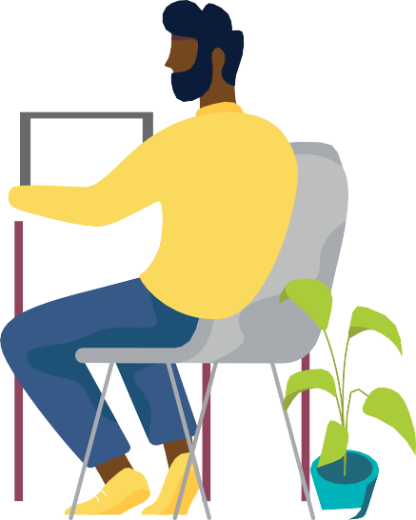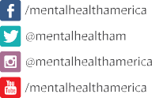 CONNECTION

If you’re taking steps to incorporate
nature into your surroundings but still feel like you’re struggling with your
mental health, you may be showing the early signs of a mental health condition.

Take a free, private screening at
mhascreening.org to help you figure out what is going on and determine
next steps.
One of the greatest benefits you get from nature is connection, which is linked to a better connection to self, community, and purpose. Time in nature benefits personal growth, self-esteem, emotional regulation, and social skills.10 When children connect with nature, they’re more imaginative and independent, and they feel more connected to the peers they’re playing with and other living things.
- Accessible nature in a neighborhood, such as parks, lakes, or gardens, are associated with an increased sense of community belonging.11
- Of respondents to MHA’s Connection Survey, people who reported not feeling connected to nature also didn’t feel connected to themselves, to others, or to spirituality/purpose.

WHAT CAN I DO TO CONNECT?
Plant something. Gardening is a great mindfulness activity. Getting your hands in the dirt can help you feel more grounded, and helping a plant grow can even boost your self-esteem.12
Practice gratitude. Nature is everywhere – even in cities, you can find places like community gardens, little courtyards, or trees full of birds and squirrels. Once you start tuning into your senses and appreciating the unexpected, it often feels more meaningful.

Sources available by downloading the 2023 May is Mental Health Month Toolkit at mhanational.org/may.

SAFE AND STABLE HOUSING
1Brown K. W., Ryan R.M. (2003). The benefits of being present: mindfulness and its role in psychological well-being. J Pers Soc Psychol. 2003 Apr;84(4):822-
48. doi: 10.1037/0022-3514.84.4.822. PMID: 12703651.
2Stiles, M. M. (December 1, 2002). Witnessing domestic violence: the effect on children. Am Fam Physician. 2002 Dec 1;66(11):2052, 2055-6, 2058 passim. PMID: 12484688.
3Mahase, E. (June 7, 2019). Women who experience domestic abuse are three times as likely to develop mental illness. BMJ 2019; 365 doi: https://doi. org/10.1136/bmj.l4126
4Harding C. F., Pytte C. L., Page K. G., Ryberg K. J., Normand E., Remigio G. J., DeStefano R. A., Morris D. B., Voronina J., Lopez A., Stalbow L. A., Williams E.P., & Abreu N. (November 18, 2019). Mold inhalation causes innate immune activation, neural, cognitive and emotional dysfunction. Brain Behav Immun. 2020 Jul;87:218-228. doi: 10.1016/j.bbi.2019.11.006. Epub 2019 Nov 18. PMID: 31751617; PMCID: PMC7231651.
5Centers for Disease Control and Prevention. (2021). National Center for Health Statistics. National Vital Statistics System, Mortality 2018-2021 on CDC WONDER Online Database, released in 2021. Data are from the Multiple Cause of Death Files, 2018-2021, as compiled from data provided by the 57 vital statistics jurisdictions through the Vital Statistics Cooperative Program. http://wonder.cdc.gov/ucd-icd10-expanded.html
6Mental Health America. (N.D.) Gun Deaths, Violence, and Mental Health. https://mhanational.org/gun-deaths-violence-and-mental-health

HEALTHY HOME ENVIRONMENTS
1Saxbe D. E., Repetti R. (2010). No place like home: home tours correlate with daily patterns of mood and cortisol. Pers Soc Psychol Bull. 2010 Jan;36(1):71-
81. doi: 10.1177/0146167209352864. Epub 2009 Nov 23. PMID: 19934011.
2McMains, S., & Kastner, S. (2011). Journal of Neuroscience. Interactions of Top-Down and Bottom-Up Mechanisms in Human Visual Cortex. 31 (2) 587-597; DOI: https://doi.org/10.1523/JNEUROSCI.3766-10.2011
3Hanley, A.W., Warner, A.R., Dehili, V.M. et al. (2015)Washing Dishes to Wash the Dishes: Brief Instruction in an Informal Mindfulness Practice. Mindfulness 6, 1095–1103 https://doi.org/10.1007/s12671-014-0360-9
4Saxbe D. E., Repetti R. (2010). No place like home: home tours correlate with daily patterns of mood and cortisol. Pers Soc Psychol Bull. 2010 Jan;36(1):71-
81. doi: 10.1177/0146167209352864. Epub 2009 Nov 23. PMID: 19934011.
5Highland, A. (July 30, 2018). Sleep Deprivation: The Effects on Mind and Body. https://www.mhanational.org/blog/sleep-deprivation-effects-mind-and- body
6Cleveland Clinic. (November 16, 2021). What’s the Best Temperature For Sleep? Health Essentials. https://health.clevelandclinic.org/what-is-the-ideal- sleeping-temperature-for-my-bedroom/
7Centers for Disease Control and Prevention. (April 1, 2020) The Color of the Light Affects the Circadian Rhythms. The National Institute for Occupational Safety and Health. https://www.cdc.gov/niosh/emres/longhourstraining/color.html
8Weeks, T. (2018). Aesthetics and Interior Design: Effects on Overall Mental Health. https://www.rmfp.com/wp-content/uploads/2022/01/Aesthetics-and- Design-LM-061818-2.pdf
9Advanced Neurotherapy. (June 19, 2020). 4 Reason Why Walking Outside Benefits the Brain. https://www.advancedneurotherapy.com/blog/2015/09/10/ walking-outside-brain#:~:text=Getting%20Fresh%20Air&text=Oxygen%20is%20absolutely%20essential%20in,to%20decreases%20in%20oxygen%20 levels
10Sleep Foundation. (January 5, 2023). If Opening a Window Leads to Better Sleep, Why Don’t We Do It? https://www.sleepfoundation.org/sleep-news/ open-window-may-be-better-for-sleep-but-we-keep-it-closed
11Zundel, C. G., Ryan, P., Cole, B., Heeter, A., Huang, Y., Strawn, J. R., & Marusak, H. A. (December, 2022). December Air pollution, depressive and anxiety disorders, and brain effects: A systematic review. NeuroToxicology, Volume 93, 2022 Pages 272-300, ISSN 0161-813X, https://doi.org/10.1016/j. neuro.2022.10.011.
12Sarris, J., Manicor, M., Hargraves, & F., Tsonis, J. (2019). Harnessing the Four Elements for Mental Health. Frontiers in Psychiatry, Volume 10, DOI=10.3389/ fpsyt.2019.00256. https://www.frontiersin.org/articles/10.3389/fpsyt.2019.00256
13Strøm-Tejsen P., Zukowska D., Wargocki P., Wyon D.P. (2015). The effects of bedroom air quality on sleep and next-day performance. Indoor Air. 2016 Oct;26(5):679-86. doi: 10.1111/ina.12254. Epub 2015 Nov 5. PMID: 26452168.
14Ma X., Yue Z. Q., Gong Z. Q., Zhang H., Duan N.Y., Shi Y.T., Wei G.X., Li Y.F. (2017). The Effect of Diaphragmatic Breathing on Attention, Negative Affect and Stress in Healthy Adults. Front Psychol. 2017 Jun 6;8:874. doi: 10.3389/fpsyg.2017.00874. PMID: 28626434; PMCID: PMC5455070.

NEIGHBORHOODS AND TOWNS
1Orminski, E. (June 30, 2021). Your Zip Code is More Important Than Your Genetic Code. National Community Reinvestment Coalition. https://ncrc.org/ your-zip-code-is-more-important-than-your-genetic-code/
2USDA. (October 20, 2022). Food Access Research. USDA Economic Research Service. https://www.ers.usda.gov/data-products/food-access-research-atlas/ documentation/
3Correll, R. (November 1, 2022. What Are Food Deserts? Very Well Health. https://www.verywellhealth.com/what-are-food-deserts-4165971
4Pryor L., Lioret S., Van Der Waerden, J., Fombonne, É., Falissard, B., & Melchior M. (2016). Food insecurity and mental health problems among a community sample of young adults. Soc Psychiatry Psychiatr Epidemiol. 2016 Aug;51(8):1073-81. doi: 10.1007/s00127-016-1249-9. Epub 2016 Jun 13. PMID: 27294729. 5American Hospital Association. (November, 2017). Social Determinants of Health Series: Transportation and the Role of Hospitals. https://www.aha.org/

ahahret-guides/2017-11-15-social-determinants-health-series-transportation-and-role-hospitals
6McKenzie T. L., Moody J. S., Carlson J. A., Lopez N. V., & Elder J.P. (2013). Neighborhood Income Matters: Disparities in Community Recreation Facilities, Amenities, and Programs. J Park Recreat Admi. 2013 Winter;31(4):12-22. PMID: 25006598; PMCID: PMC4082954.
7Hwang, J., & Ding, L. (June 2020). Unequal Displacement: Gentrification, Racial Stratification, and Residential Destinations in Philadelphia. Forthcoming in American Journal of Sociology. https://sociology.stanford.edu/sites/sociology/files/hwang_ding_unequal_displacement_forthcoming.pdf
8Tran L. D., Rice T. H., Ong P. M., Banerjee S., Liou J., & Ponce N.A. (January 20, 2020). Impact of gentrification on adult mental health. Health Serv Res. 2020 Jun;55(3):432-444. doi: 10.1111/1475-6773.13264. Epub 2020 Jan 20. PMID: 31957022; PMCID: PMC7240775.
9Lim, S., Chan, P. Y., Walters, S., Culp, G., Huynh, M., & Gould, H. (2017). Why Gentrification and Mental Health Go Hand in Hand. New York City Department of Health and Mental Hygiene. https://housingmatters.urban.org/research-summary/why-gentrification-and-mental-health-go-hand-hand
10Dragan, K. L., Ellen, I.G., & Glied, S. A. (September 2019). Gentrification And The Health Of Low-Income Children in New York City. https://doi.org/10.1377/ hlthaff.2018.05422
11Bowe, M., Wakefield, J. R. H., Kellezi, B., Stevenson, C., McNamara, N., Jones, B. A., Sumich, A.,& Heym, N. (April 2021). The mental health benefits of community helping during crisis: Coordinated helping, community identification and sense of unity during the COVID-19 pandemic. Journal of Community & Applied Social Psychology / Volume 32, Issue 3, p. 521-535. https://doi.org/10.1002/casp.2520
12Dahal S., Swahn M. H., Hayat M. J. (April 23, 2018). Association between Neighborhood Conditions and Mental Disorders among Children in the US: Evidence from the National Survey of Children’s Health 2011/12. Psychiatry J. 2018 Apr 23;2018:5914315. doi: 10.1155/2018/5914315. PMID: 29850471; PMCID: PMC5937453.
13Centers for Disease Control and Prevention. (June 8, 2022). Violence Prevention: Community Violence Program. https://www.cdc.gov/violenceprevention/ communityviolence/index.html
14Lee, E., Larkin, H., & Esaki, N. (May 3, 2018). Exposure to Community Violence as a New Adverse Childhood Experience Category: Promising Results and Future Considerations. Volume 98, Issue 1. https://doi.org/10.1606/1044-3894.2017.10
15National Public Radio. (September 8, 2022). A Quarter of U.S. Adults Fear Being Attacked in Their Neighborhood, a poll finds. https://www.npr. org/2022/09/08/1120099696/americans-fear-attacked-neighborhood-poll
16Borofsky L. A., Kellerman I., Baucom B., Oliver P. H., & Margolin G. (October 1, 2013). Community Violence Exposure and Adolescents’ School Engagement and Academic Achievement Over Time. Psychol Violence. 2013 Oct 1;3(4):381-395. doi: 10.1037/a0034121. PMID: 24163782; PMCID: PMC3806333.
17McGill, T. M., Self-Brown, S. R., Lai, B. S., Cowart-Osborne, M., Tiwari, A., LeBlanc, M., & Kelley, M. L. (February 7, 2014). Effects of exposure to community violence and family violence on school functioning problems among urban youth: the potential mediating role of posttraumatic stress symptoms. Front. Public Health, Sec. Children and Health, Volume 2. https://doi.org/10.3389/fpubh.2014.00008
18McDaniels, A. (July 23, 2021). Overpolicing erodes communities, yet the research of new strategies is mixed. Center for Health Journalism. https:// centerforhealthjournalism.org/2021/07/23/overpolicing-brutalizes-communities-yet-research-alternatives-mixed
19Beck, B. (2020). Policing Gentrification: Stops and Low-Level Arrests during Demographic Change and Real Estate Reinvestment. Housing Matters. https:// housingmatters.urban.org/research-summary/neighborhoods-gentrify-police-presence-increases
20Movement Advancement Project. (April 2019). Where We Call Home: LGBT People in Rural America. www.lgbtmap.org/rural-lgbt
21Amherst H Wilder Foundation. (November 30, 2021). What keeps us safe? How social conditions create community safety. https://www.wilder.org/ articles/what-keeps-us-safe-how-social-conditions-create-community-safety

THE OUTDOORS AND NATURE
1American Psychological Association. (April 1, 2020). Nurtured by nature. Monitor on Psychology, 51(3). https://www.apa.org/monitor/2020/04/nurtured- nature
2Engemann K., Pedersen C. B., Arge L., Tsirogiannis C., Mortensen P.B., & Svenning J.C. (February 25, 2019). Residential green space in childhood is associated with lower risk of psychiatric disorders from adolescence into adulthood. Proc Natl Acad Sci U S A. 2019 Mar 12;116(11):5188-5193. doi: 10.1073/ pnas.1807504116. Epub 2019 Feb 25. PMID: 30804178; PMCID: PMC6421415.
3Han K. T., Ruan L. W., & Liao L. S. (June 17, 2022). Effects of Indoor Plants on Human Functions: A Systematic Review with Meta-Analyses. International Journal of Environmental Research and Public Health. 2022; 19(12):7454. https://doi.org/10.3390/ijerph19127454
4Conklin, L. M. (November 25, 2022). The Best Air-Cleaning Plants, according to NASA. The Healthy. https://www.thehealthy.com/home/plants-to-detoxify- your-home/
5Mental Health America. (2022) What Is Serotonin? https://www.mhanational.org/what-serotonin
6Monash University (2021) Natural Light May Be Key to Improving Mood and Reducing Insomnia. https://neurosciencenews.com/natural-light-insomnia- mood-19456/
7Morales-Bravo, J. and Navarrete-Hernandez, P. (2002). Enlightening wellbeing in the home: The impact of natural light design on perceived happiness and sadness in residential spaces. Building and Environment. https://www.sciencedirect.com/science/article/pii/S0360132322005509
8Harvard Medical School. (2008). Staying Healthy: Time for more vitamin D. Harvard Health Publishing. https://www.health.harvard.edu/staying-healthy/ time-for-more-vitamin-d
9Nall, R. (2019) What are the Benefits of Sunlight? Healthline. https://www.healthline.com/health/depression/benefits-sunlight
10Capaldi, C. A., Passmore, H.-A., Nisbet, E. K., Zelenski, J. M., & Dopko, R. L. (2015). Flourishing in nature: A review of the benefits of connecting with nature and its application as a wellbeing intervention. International Journal of Wellbeing, 5(4), 1-16. do i:10.5502/ijw.v5i4.449
11Rugel, E. J., Carpiano, R. M., Henderson, & S. B., Brauer, M. (April, 2019). Exposure to natural space, sense of community belonging, and adverse mental health outcomes across an urban region. Environmental Research, Volume 171, 2019, Pages 365-377, ISSN 0013-9351. https://doi.org/10.1016/j. envres.2019.01.034.
12Hoffman, A. J., Thompson, D., & Cruz, A. (2004). The Community College Enterprise; Livonia Vol. 10, Iss. 1, (Spring 2004): 91-101. https://www.proquest. com/docview/218800068

WORKSHEET:
SHAPING YOUR HOME ENVIRONMENT

On a scale from 1-10, how satisfied are you with your space?
What do you want to feel when you’re in your space? What might you want to change about the space to help create those feelings?

Thinking about your space, what do you already love about it? Write your answers to the prompts below in the heart shapes.
- Something that makes you feel happy.
- Something that makes you feel cozy.
- Something that makes you feel safe.
- Something that makes you feel connected.
- Something that makes you feel like you.

What do you feel like your space is missing? This can be an item, an overall aesthetic, a feeling, or another factor. Write your answers in the roof of the house.

What are one or two things you can do right away to bring more of what you want into your space? Write your answers in the moving boxes.

WORKSHEET:
OPENING YOUR MIND TO THE OUTDOORS

Sometimes it’s hard to do the things we want to do – and it’s especially hard to do the things we don’t want to do but know are good for us. You can boost your motivation by thinking about how to connect your goal to positive feelings.

GUIDED MEDITATION
For 30-60 seconds, close your eyes and think about being outdoors. How do you feel? What do you see? What is around you? Light? Wind? What does it smell like? What does it sound like? Open your eyes. Below jot down some notes about what benefits you felt being outdoors. Push aside any thoughts about what you “should” feel and really think about the positives about spending some of your time outdoors.

PLANNING
What is one thing you can do in the next week or two to spend time outdoors for your mental health? In MHA’s Connection Survey, 68% of people answered “taking a walk” – that’s often the first activity that comes to mind, but you have other options too! Anything that gets you outside counts as a starting point. (Examples: reading in the backyard, exercising in the park, a camping trip, etc.)

BUILDING MOTIVATION
Motivation is tied to pleasure or the avoidance of pain or fear. We feel motivation from things we say or feel inside our minds or from things we get from others or outside ourselves. What gets you motivated? What helps you feel accomplished, appreciated, or loved? (Examples: checking off a to-do list, hearing verbal praise, spending time with others, doing things that relate to my values, etc.)

PLANNING INTO ACTION
Now that you’ve done some reflecting, it’s time to start preparing for action. How can you make your answers to “Planning” and “Building Motivation” work together? Or, when working toward your goal, what can you do to keep your mind on the positive it brings to your life? (Examples: When I take a walk, I’ll check it off my list; I’ll share goals and wins with friends for praise; etc.)

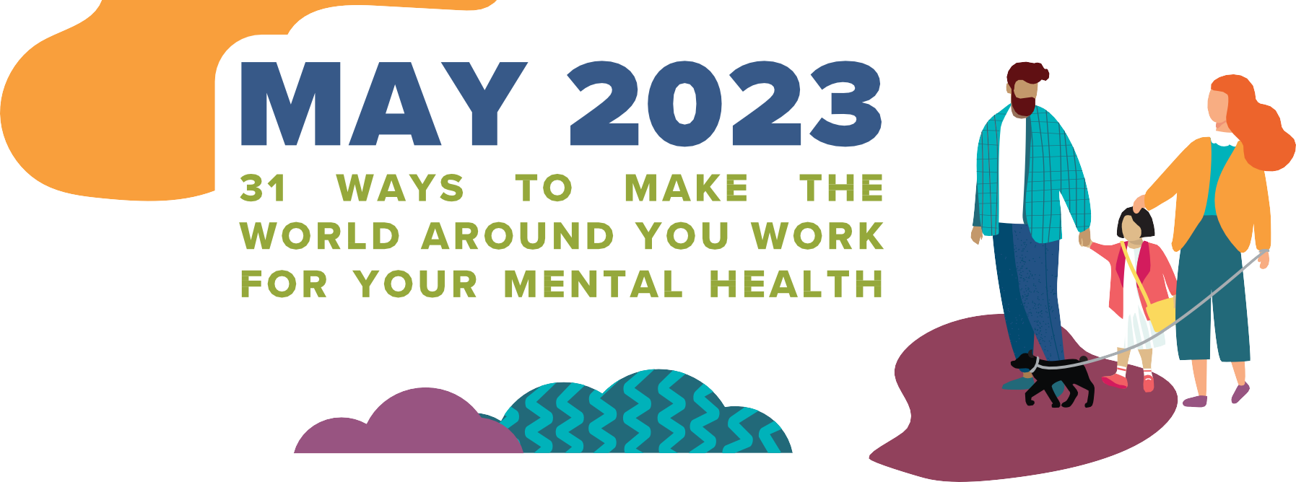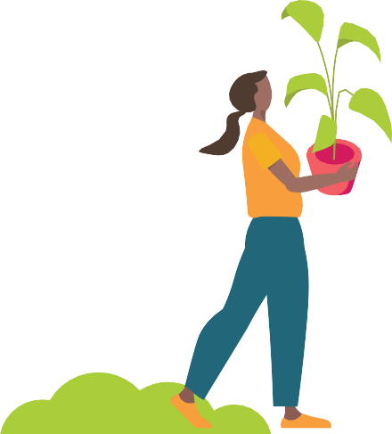

SUNDAY MONDAY TUESDAY WEDNESDAY THURSDAY FRIDAY SATURDAY

 | 1  Try to find 15 minutes to get some sunlight – if that isn't an option, use a daylight lamp or a blue light lamp when you spend all day indoors. | 2  Create a "favorite things" corner, basket, or space with pictures of people/things you love, textures that bring you joy, or your favorite color. | 3  Remember that your mind and body are connected. Use your space to assist you with physical movement – find a good spot to stretch, practice yoga, or do other exercises that you can do at home. | 4  Surround yourself with loved ones (if not physically in person, seek out communities online). | 5  Write down affirmations or notes that you can look at throughout your day. These could go in your home or car to serve as reminders as you go about your day. | 6  Play music instead of watching TV when you have downtime at home.
7  Do some spring cleaning with mental health in mind! Remove objects in your home that might trigger negative thoughts or habits. | 8  Put pictures of loved ones or pets in places you often look to stir positive thoughts and feelings throughout the day. | 9  Set a timer and clean whatever you can in 10 minutes. Try doing this daily to tackle cleaning up your space in a  non-overwhelming way. | 10  Stop and smell the roses...literally. Studies show that being surrounded by nature is a mood booster. While you’re at it, consider adding plants to your space. They will improve air quality and cognitive functioning. | 11  Get comfortable and read a good book. Reading can help relieve stress and tension by serving as a temporary distraction. | 12  Hold the door for a stranger or sign up to volunteer for your favorite charity. Studies show that random acts of kindness increase release of oxytocin – the “feel good” hormone. | 13  Take the stairs instead of the elevator, or park your car farther away from the store. Even small additions of exercise throughout the day can decrease tension and improve sleep.
14  Incorporate your favorite color into your living space – if you can't paint walls, use art, pillows, blankets, or curtains. | 15  Do you work from home? Setting up a designated workspace in your home is ideal, but if you don't have the option of an office, at least keep your work out of your bedroom. | 16  Air pollution can speed up cognitive decline – change the filter in your furnace regularly, clean dust often, buy an air purifier if you can, or use houseplants to improve air quality. | 17  Try prepping your lunches or picking out your work clothes the night before. You'll save some time in the morning and start the day with a sense of control. | 18  Keep it cool for a good night's sleep. The optimal temperature for sleep is between 60 degrees and 67 degrees Fahrenheit. | 19  Keep hobby supplies easily accessible for when you are stressed or need a creative outlet. | 20  Dance around while you do your housework. Not only will you get chores done, but dancing reduces levels of cortisol (the stress hormone) and increases endorphins (the body's "feel-good" chemicals).
21 | 22 | 23 | 24 | 25 | 26 | 27
Use scents you like in your spaces. This could be lighting candles, using diffusers, or even creating DIY smells (for example, boiling oranges and cinnamon on the stove). | Use noise-canceling headphones or earplugs to block out noise at home. Especially if the sound of specific people or things gets triggering, or if you find yourself getting overstimulated. | Make your sleep environment as dark as possible. Try blackout curtains or use a sleep mask. | Keep things that nourish your primary needs easy to access (snacks, water, blankets for bedtime, etc.). | Try creating a stim box filled with fidgets or soft things to occupy your hands when you feel stressed, anxious, or need help focusing. | Try listening to white noise if you have trouble falling asleep. You can use a white noise machine, phone app, or turn on a fan. | Give yourself a break! Take 10 minutes out of your day for a walk. Small breaks (and exercise) improve your ability to deal with stress.
28  Consider changing the settings on your phone to "do not disturb" or mute your notifications when possible. | 29  After you're done using something, put it away, don't just put it down – this can help prevent clutter and piles of stuff from accumulating. | 30  Try keeping a journal or notepad by your bedside. If you struggle with shutting your mind off at night, write down your thoughts to attempt to clear your mind and find rest. | 31  Make a wall or jar of gratitude where you write things you are thankful for, that bring you joy, or positively impact your mental health. |  |  | 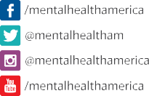

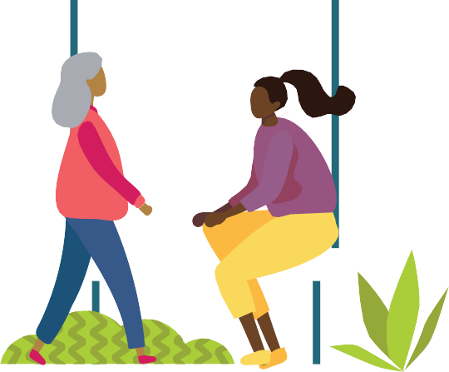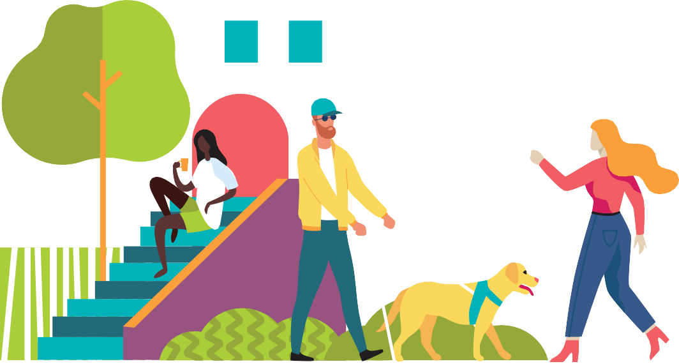

MANY FACTORS COME INTO PLAY WHEN IT COMES TO MENTAL HEALTH.

TAKE SOME TIME TO LOOK AROUND AND MAKE NOTE OF YOUR SURROUNDINGS, AND LOOK WITHIN TO SEE HOW THEY MIGHT BE AFFECTING YOU.

LEARN MORE ABOUT HOW YOUR ENVIRONMENT IMPACTS YOUR MIND AND WHAT YOU CAN DO ABOUT IT AT MHANATIONAL.ORG/MAY.

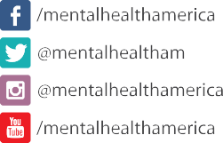

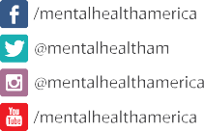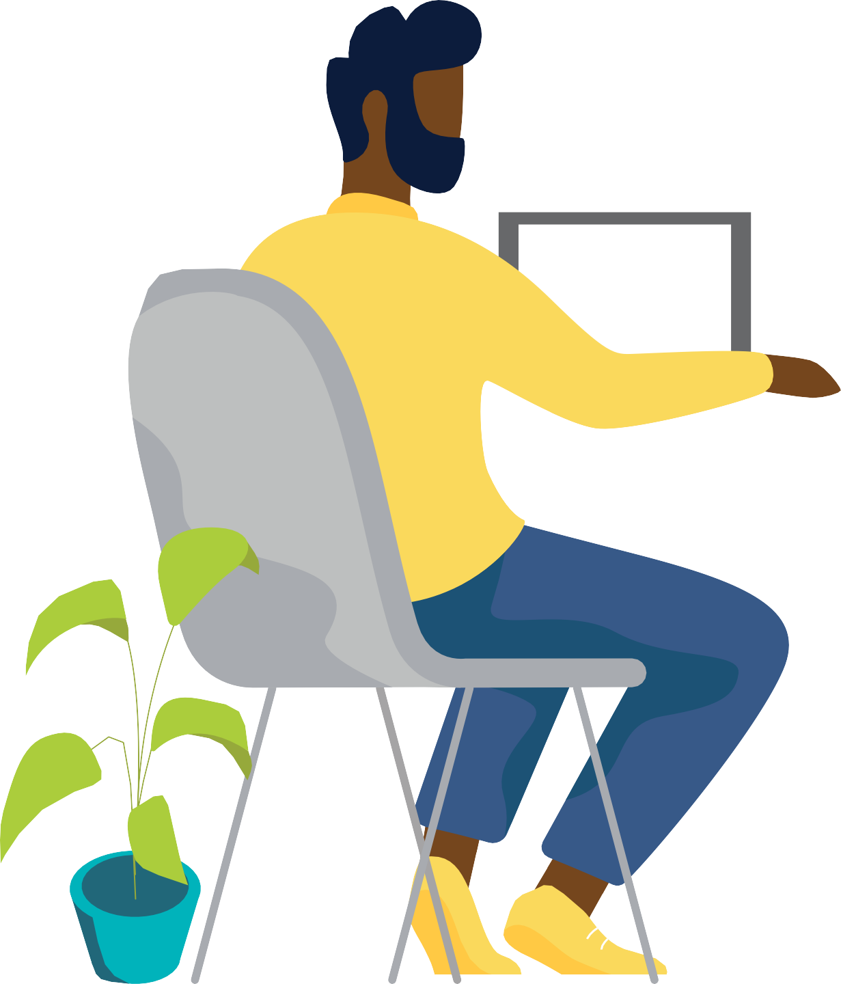MAY IS MENTAL HEALTH MONTH

MANY FACTORS COME INTO PLAY WHEN IT COMES TO MENTAL HEALTH.

TAKE SOME TIME TO LOOK AROUND AND MAKE NOTE OF YOUR SURROUNDINGS, AND LOOK WITHIN TO SEE HOW THEY MIGHT BE AFFECTING YOU.

A MENTAL HEALTH TEST IS ONE OF THE EASIEST WAYS TO CHECK IN ON YOURSELF IF SOMETHING DOESN’T FEEL QUITE RIGHT.

MHASCREENING.ORG

